Ex. No. 9 | Working with MongoDB Using Shell Commands
Date of Exercise | 25.09.2026
GitHub Host Link | https://gautham75.github.io/Web-Technology-Lab/

Aim
To study MongoDB and perform basic database operations using MongoDB Shell (mongosh), including database and collection creation, document insertion, retrieval, filtering, sorting, updating, deletion, indexing, and simple aggregation.
1. Software Required
- MongoDB Community Server
- MongoDB Shell (mongosh)
After installation, start the MongoDB service and open a terminal or command prompt. Verify the shell with:
mongosh
If MongoDB is running locally, the shell connects to the local server and a prompt similar to the following appears:
test>

2. Basic MongoDB Structure
Before starting the commands, explain the relationship between relational database terminology and MongoDB terminology.
Relational Database | MongoDB
Database | Database
Table | Collection
Row | Document
Column | Field
Primary Key | _id

Example MongoDB document:
{
rollno: 101,
name: “Arun”,
department: “CSE”,
marks: 85
}

3. Check Existing Databases
Displays the databases currently visible to the MongoDB server.
show dbs

4. Create / Select a Database
Selects the database named collegeDB. MongoDB may not physically create it until data is stored.
use collegeDB

5. Check the Current Database
Expected output: collegeDB
db

6. Create a Collection
Creates a collection named students.
db.createCollection( “students” )

7. View Collections
Displays the collections in the current database.
show collections

8. Insert One Document
MongoDB inserts the document and automatically generates an _id if one is not supplied.
db.students.insertOne({
rollno: 101,
name: “Arun”,
department: “CSE”,
year: 3,
marks: 85
})

9. Insert Multiple Documents
insertMany() is used to insert several documents in one operation.
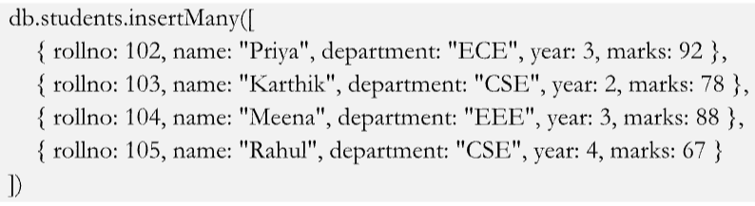

10. Display All Documents
Retrieves all documents from the students collection.
db.students.find()

11. Find One Document
Retrieves one document matching the specified filter.
db.students.findOne({ rollno: 103 })

12. Search Using a Condition
The object inside find() is called the query filter.
db.students.find({ department: “CSE” })
13. Comparison Operators
Use comparison operators to filter numeric or other comparable values.
Marks greater than 80
db.students.find({ marks: { $gt: 80 } })
Marks greater than or equal to 80
db.students.find({ marks: { $gte: 80 } })
Marks less than 80
db.students.find({ marks: { $lt: 80 } })
Marks less than or equal to 80
db.students.find({ marks: { $lte: 80 } })
Marks not equal to 85
db.students.find({ marks: { $ne: 85 } })
Operator | Meaning
$gt | Greater than
$gte | Greater than or equal
$lt | Less than
$lte | Less than or equal
$eq | Equal
$ne | Not equal
$in | Matches values in an array
$nin | Does not match values

14. Using AND Condition
Multiple fields in the same query filter are treated as an implicit AND.
db.students.find({
department: “CSE”,
marks: { $gt: 75 }
})

15. Using OR Condition
Returns students who belong to CSE or ECE.
db.students.find({
$or: [
{ department: &quot;CSE&quot; },
{ department: &quot;ECE&quot; }
]
})

16. Projection
Projection controls which fields are returned. 1 includes a field and 0 excludes it.
db.students.find(
{},
{ name: 1, marks: 1, _id: 0 }
)

17. Sort Documents
Use 1 for ascending order and -1 for descending order.
db.students.find().sort({ marks: 1 })
db.students.find().sort({ marks: -1 })

18. Limit the Results
Returns only the top three documents after sorting marks in descending order.
db.students.find()
.sort({ marks: -1 })
.limit(3)

19. Count Documents
Counts all documents or only those matching a filter.
db.students.countDocuments({})
db.students.countDocuments({ department: “CSE” })

20. Update One Document
Updates one matching document.
db.students.updateOne(
{ rollno: 101 },
{ $set: { marks: 90 } }
)

21. Update Multiple Documents
Adds or changes the status field for all matching CSE students.
db.students.updateMany(
{ department: “CSE” },
{ $set: { status: “Active” } }
)

22. Increment a Numeric Value
The $inc operator increases the numeric value by the given amount.
db.students.updateOne(
{ rollno: 103 },
{ $inc: { marks: 5 } }
)

23. Delete One Document
Deletes one document matching the filter.
db.students.deleteOne({ rollno: 105 })
24. Delete Multiple Documents
Deletes all documents matching the filter. Perform this only after earlier exercises that need the data.
db.students.deleteMany({ marks: { $lt: 70 } })

25. Distinct Values
Returns the different department values present in the collection.
db.students.distinct( “department” )

26. Simple Aggregation
Find the average marks department-wise:
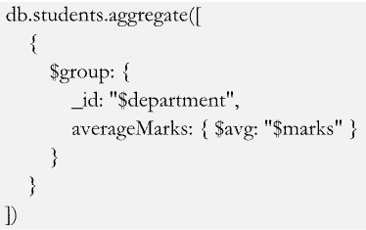

27. Find Maximum Marks
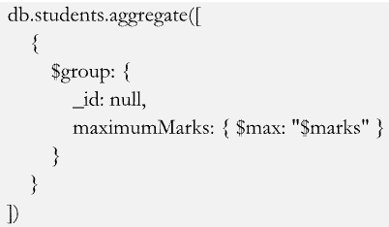
Related aggregation operators: $min for minimum, $avg for average, and $sum for total.

28. Department-wise Number of Students
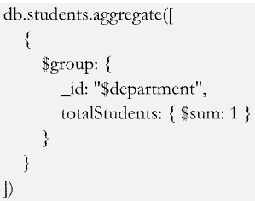

29. Create and View an Index
db.students.createIndex({ rollno: 1 })
db.students.getIndexes()
Introduce indexing only briefly in the first lab. Students should first understand documents, collections, queries, and CRUD operations.

30. Get Help in MongoDB Shell
db.students.help()
db.students.insertOne.help()

31. Drop a Collection
Use this only at the end of the experiment because it deletes the collection and its documents.
db.students.drop()

32. Drop the Database
First confirm the current database, then drop it only at the end of the lab.
db
db.dropDatabase()

33. Recommended Student Lab Sequence
Step | Student Activity | Command
1 | Start shell | mongosh
2 | View databases | show dbs
3 | Select database | use collegeDB
4 | Create collection | db.createCollection( “students” )
5 | View collections | show collections
6 | Insert one record | insertOne()
7 | Insert multiple records | insertMany()
8 | Display records | find()
9 | Search one record | findOne()
10 | Conditional search | $gt, $lt, etc.
11 | Logical queries | $and, $or
12 | Projection | find({}, {...})
13 | Sorting | sort()
14 | Limit output | limit()
15 | Count records | countDocuments()
16 | Modify one record | updateOne()
17 | Modify several records | updateMany()
18 | Delete record | deleteOne()
19 | Distinct values | distinct()
20 | Aggregation | aggregate()

34. Student Practice Problem
Create a database named collegeDB and a collection named students. Each student document should contain the following fields:
- rollno
- name
- department
- year
- marks
- city
Perform the following operations independently:
use collegeDB
db.createCollection("students")
1. Insert at least 10 student documents.

db.students.insertMany([
{ rollno: 201, name: "Arun", department: "CSE", year: 3, marks: 85, city: "Chennai" },
{ rollno: 202, name: "Priya", department: "ECE", year: 3, marks: 92, city: "Coimbatore" },
{ rollno: 203, name: "Karthik", department: "CSE", year: 2, marks: 78, city: "Salem" },
{ rollno: 204, name: "Meena", department: "EEE", year: 3, marks: 88, city: "Madurai" },
{ rollno: 205, name: "Rahul", department: "CSE", year: 4, marks: 67, city: "Trichy" },
{ rollno: 206, name: "Divya", department: "ECE", year: 2, marks: 81, city: "Chennai" },
{ rollno: 207, name: "Vijay", department: "IT", year: 3, marks: 75, city: "Erode" },
{ rollno: 208, name: "Anitha", department: "CSE", year: 3, marks: 95, city: "Coimbatore" },
{ rollno: 209, name: "Santhosh", department: "EEE", year: 4, marks: 72, city: "Salem" },
{ rollno: 210, name: "Kavya", department: "ECE", year: 3, marks: 89, city: "Madurai" }
])
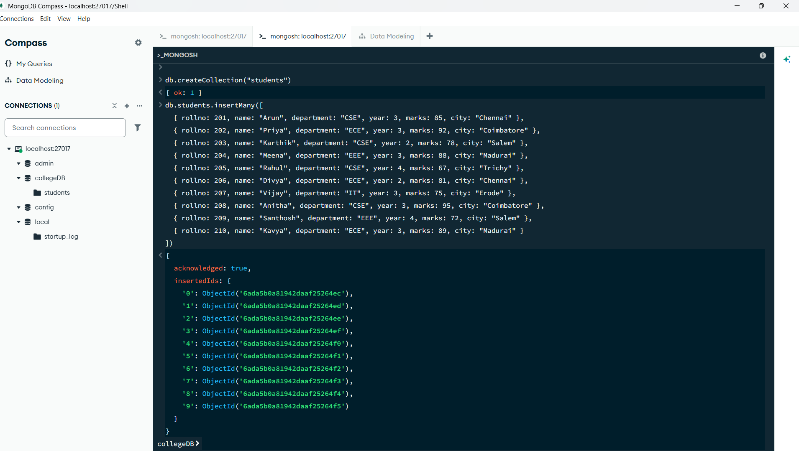

2. Display all students.
db.students.find()

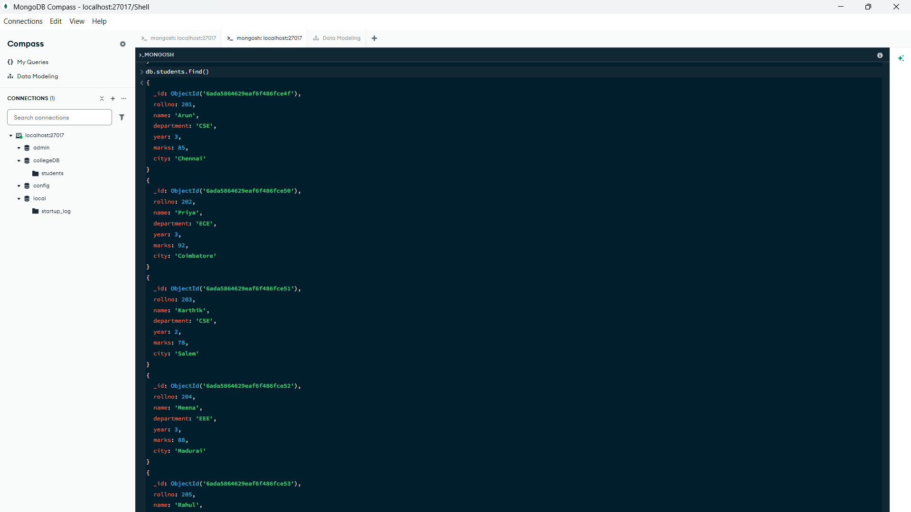
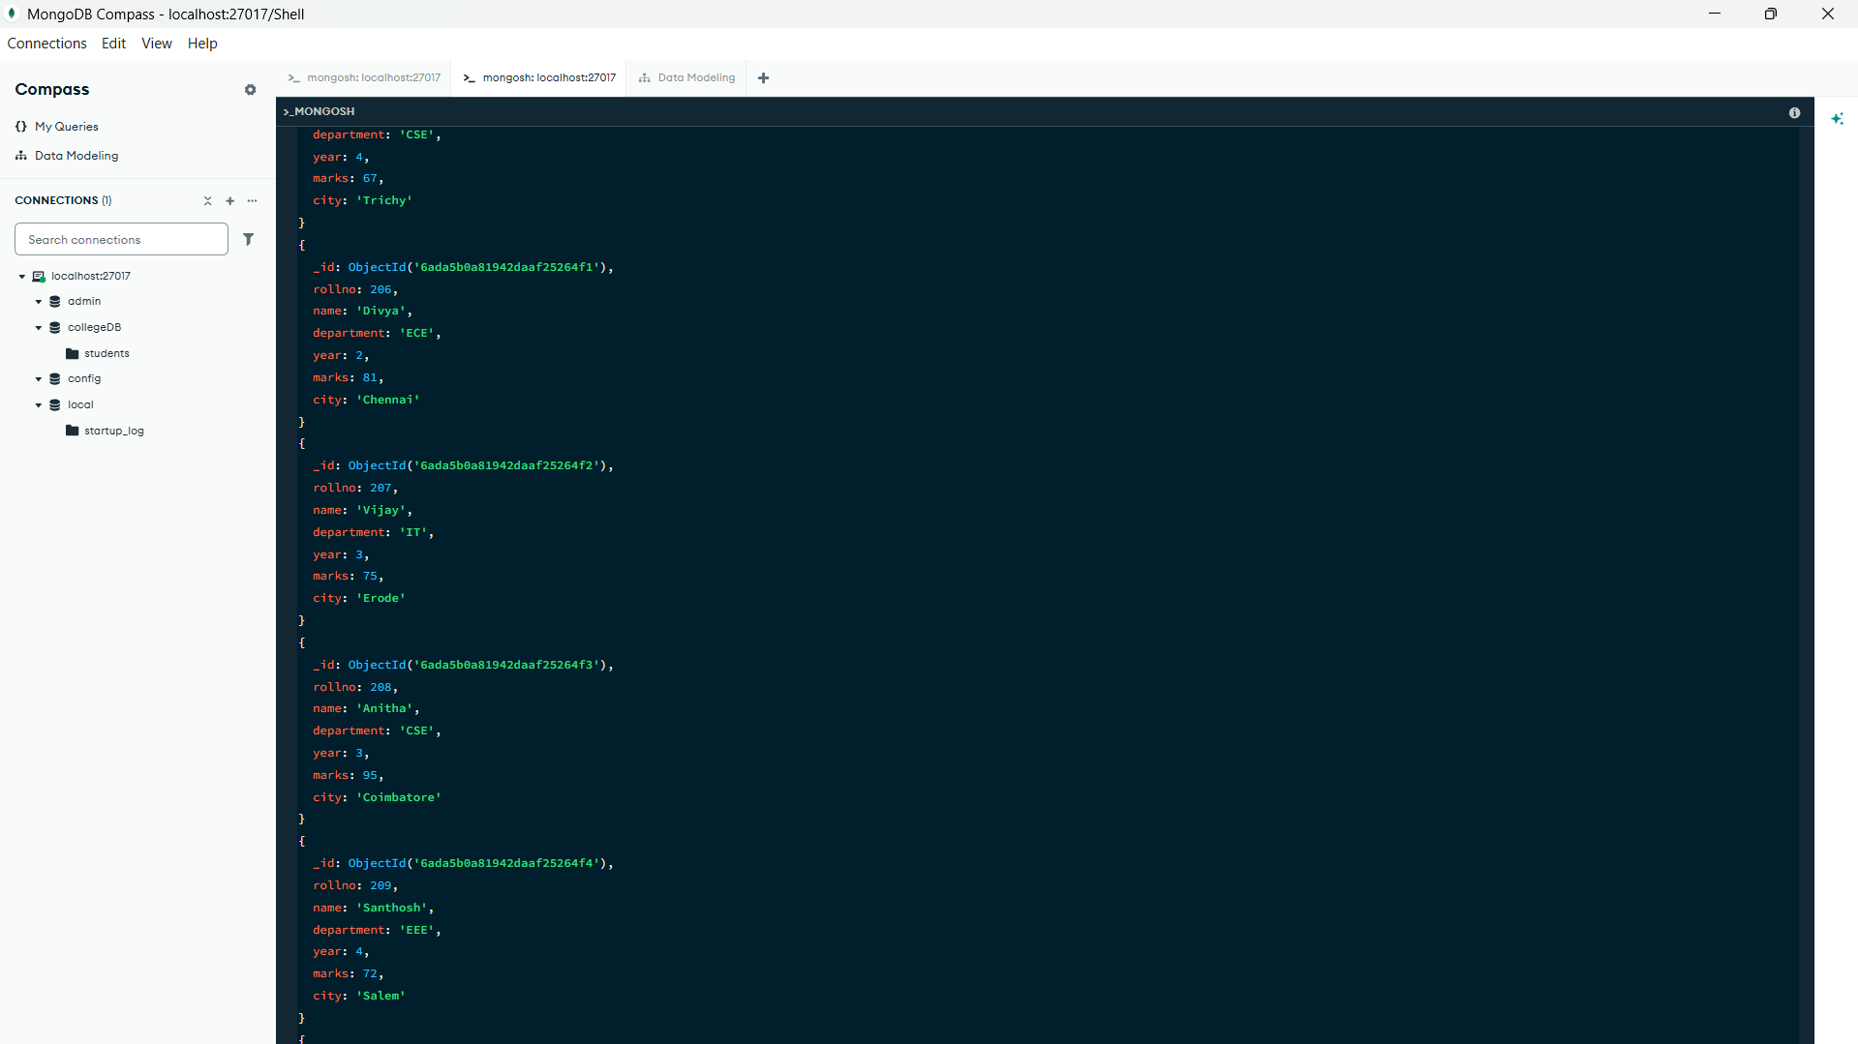

3. Display students belonging to CSE.
db.students.find({ department: "CSE" })

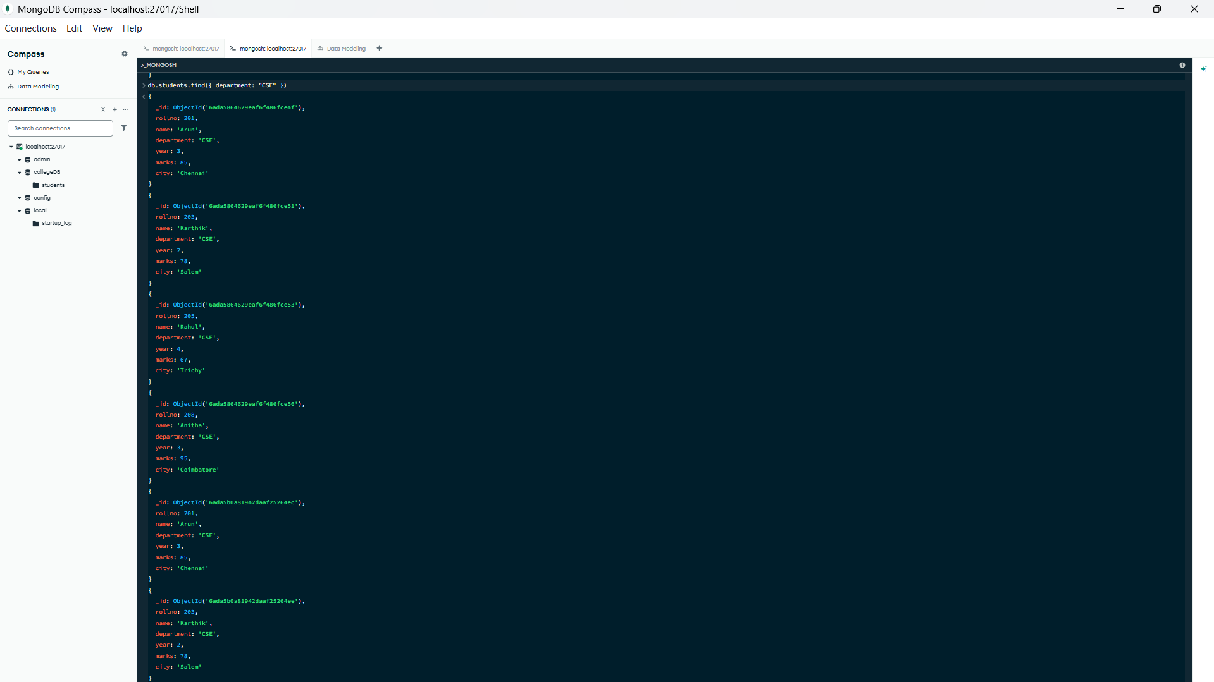

4. Find students having marks greater than 80.
db.students.find({ marks: { $gt: 80 } })
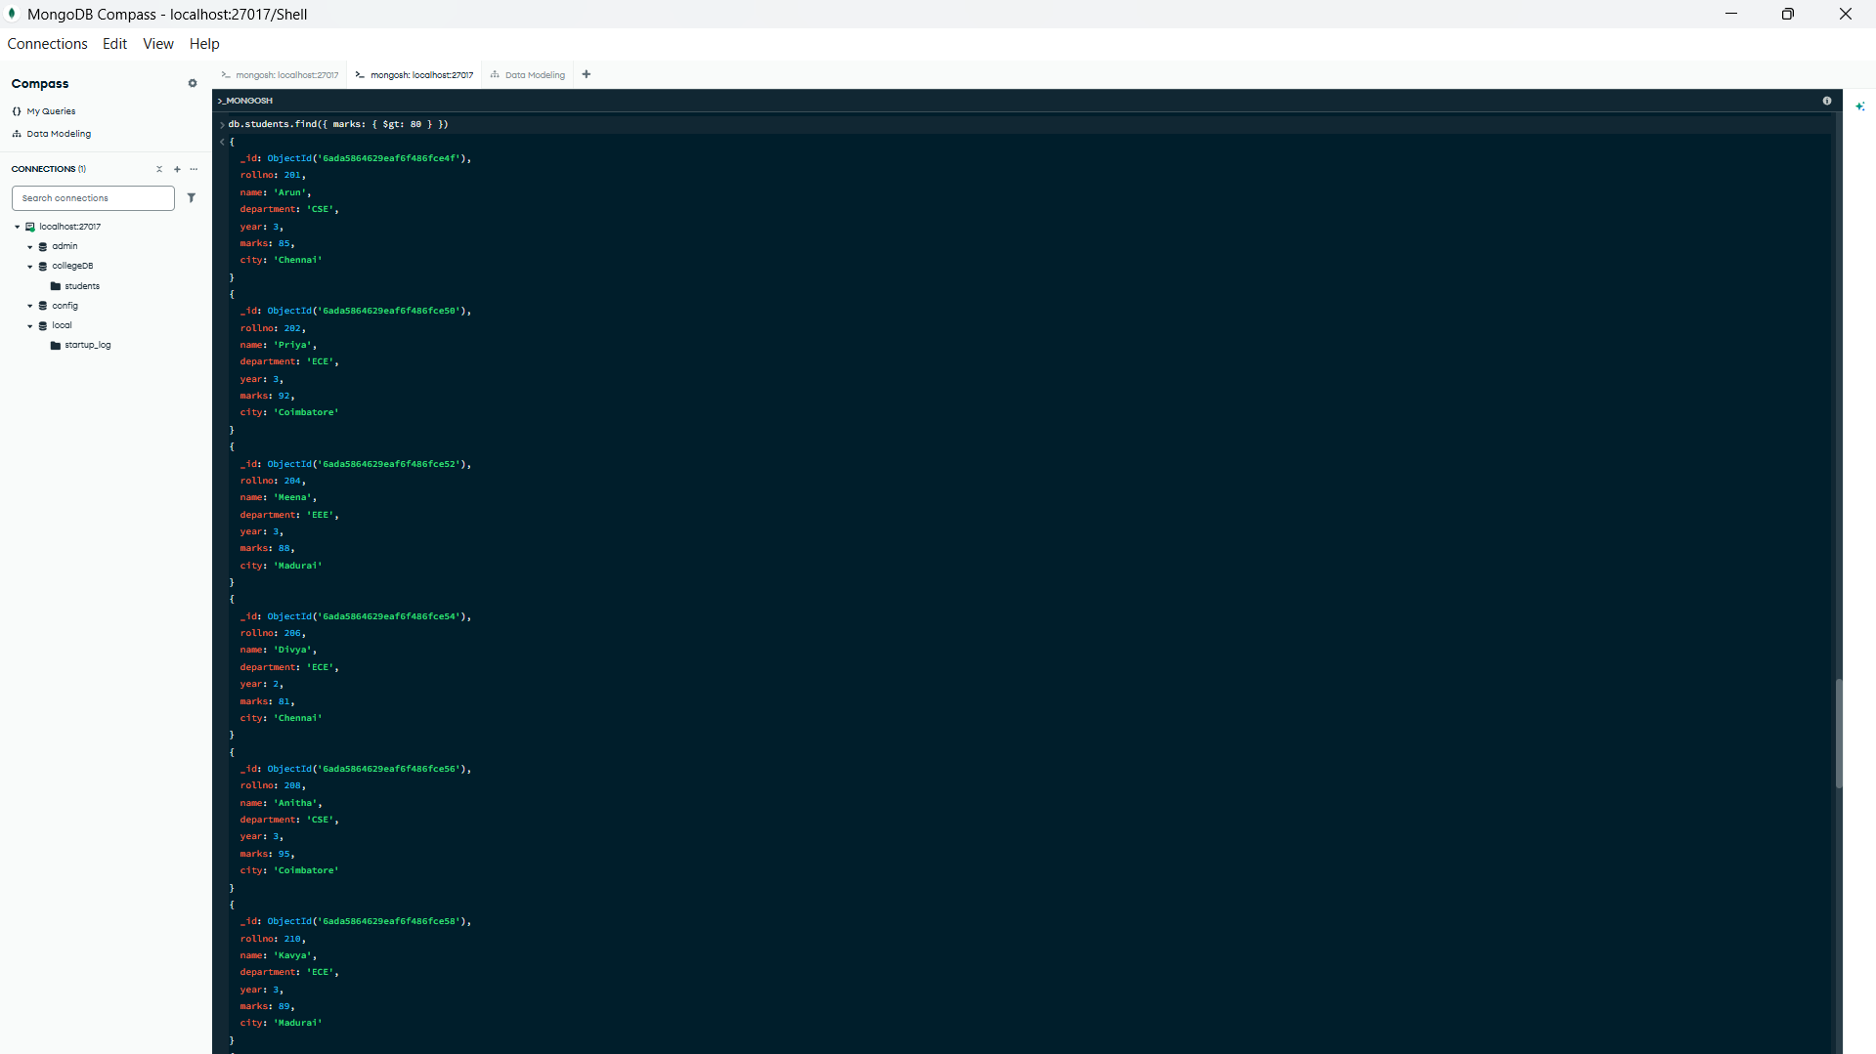

5. Display only student name and marks.
db.students.find({}, { name: 1, marks: 1, _id: 0 })
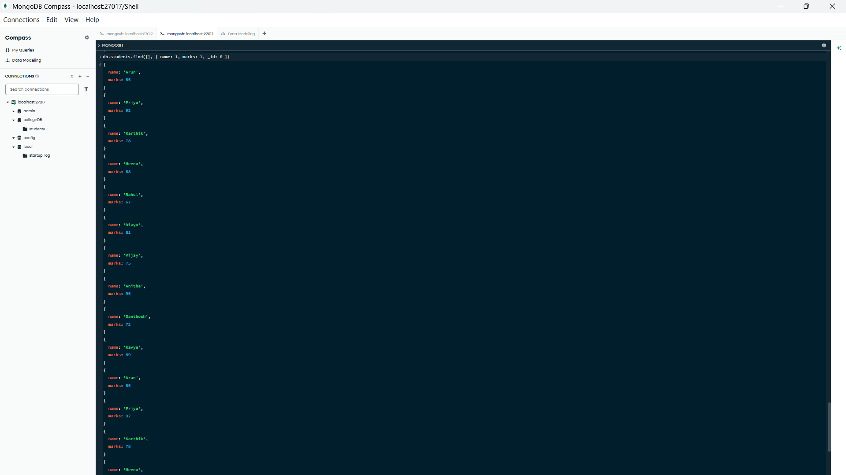
6. Find students belonging to CSE and third year.
db.students.find({ department: "CSE", year: 3 })

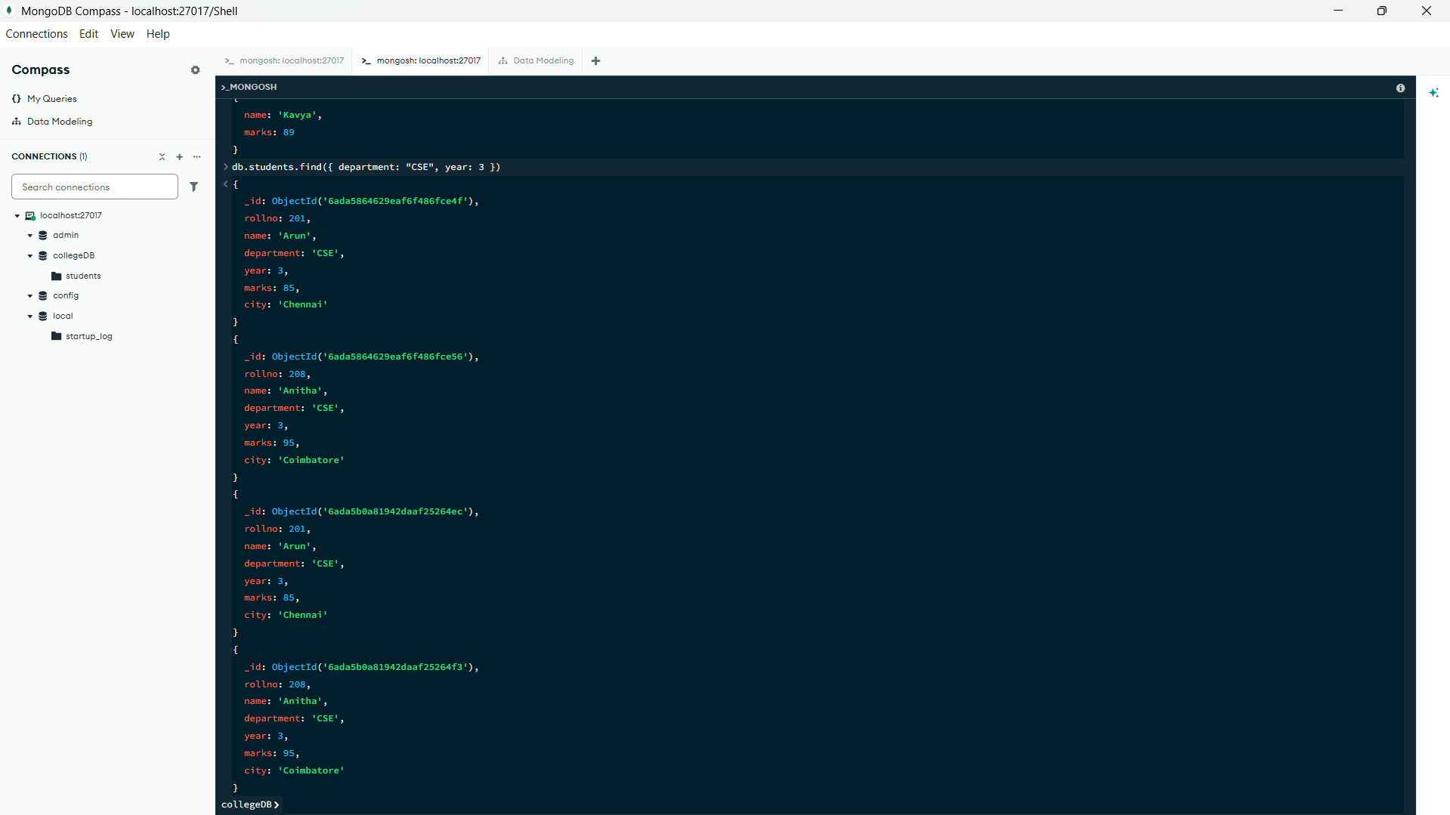

7. Find students belonging to CSE or ECE.
db.students.find({
$or: [
{ department: "CSE" },
{ department: "ECE" }
]
})
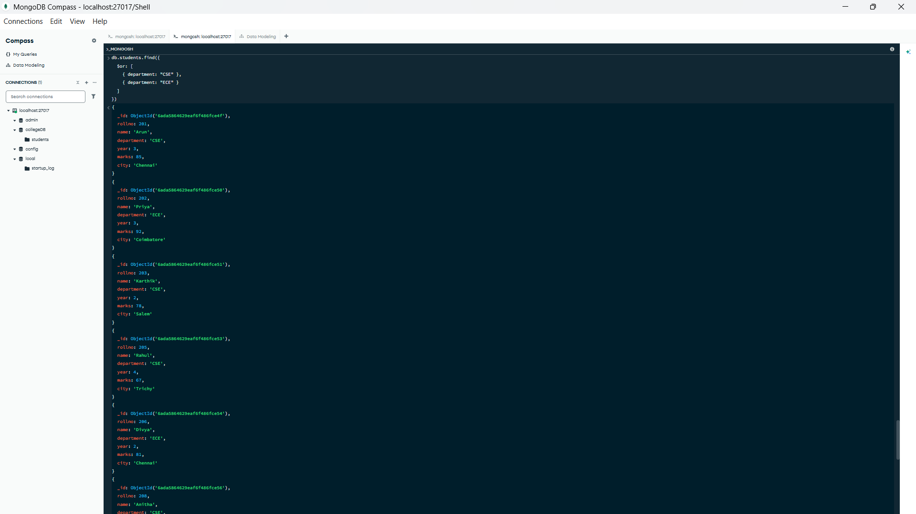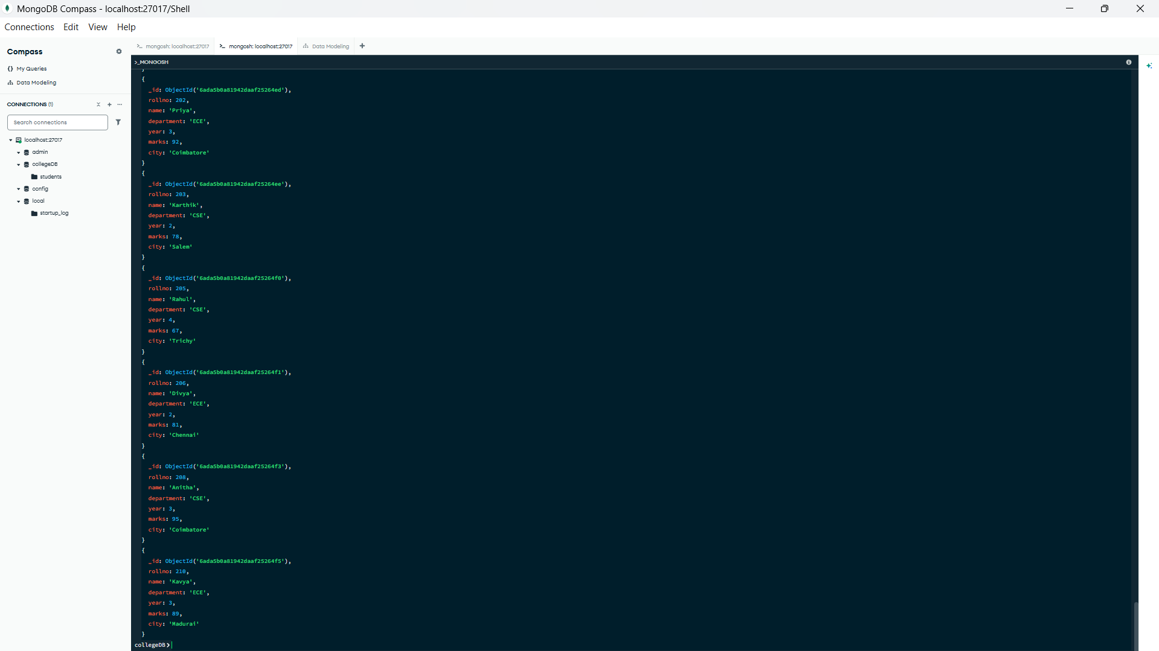

8. Sort students based on marks.
Ascending order :-
db.students.find().sort({ marks: 1 })

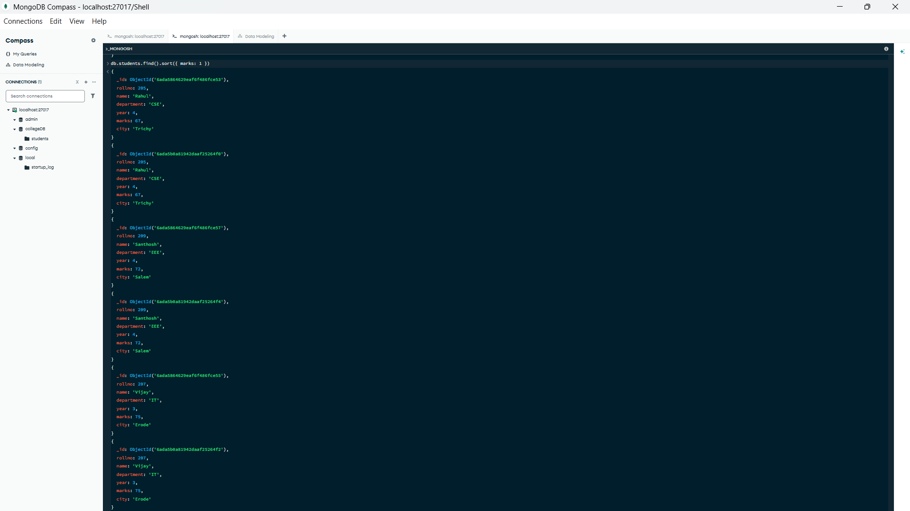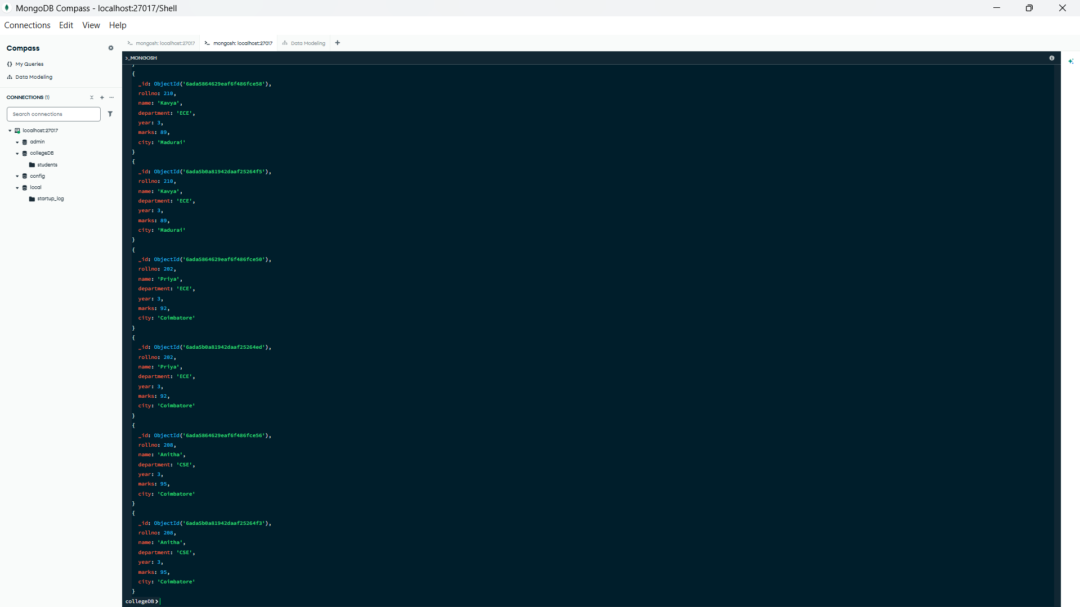

Descending order :-
db.students.find().sort({ marks: -1 })

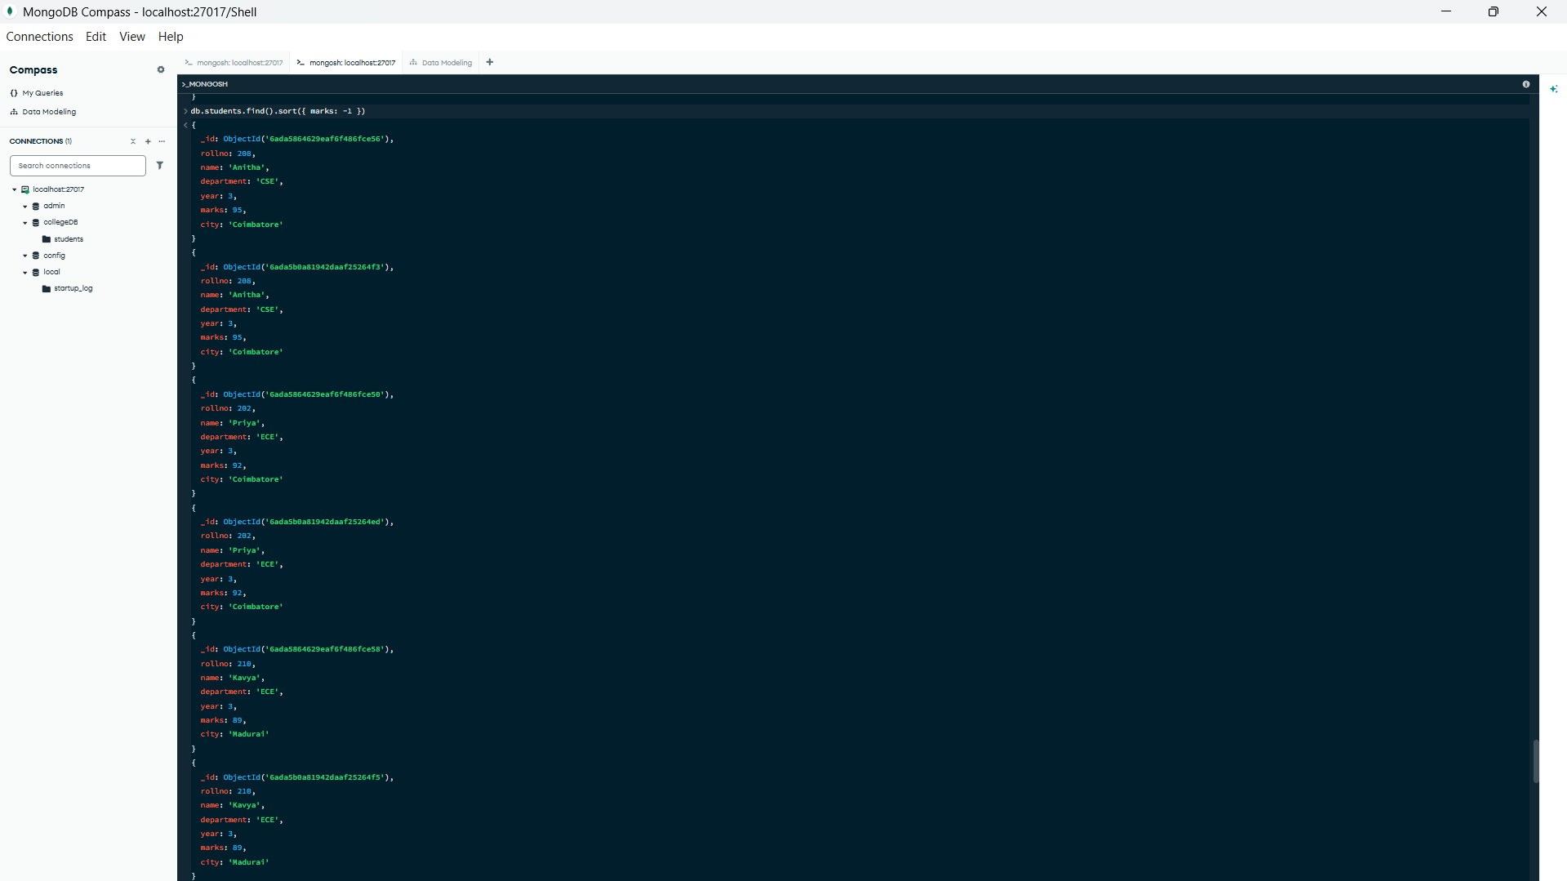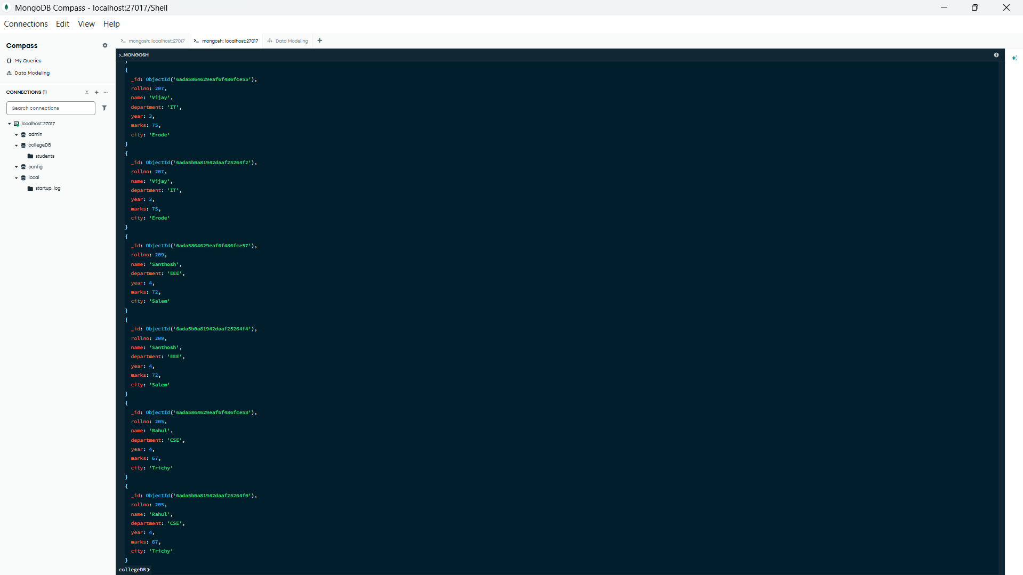

9. Display the top three students based on marks.
db.students.find().sort({ marks: -1 }).limit(3)

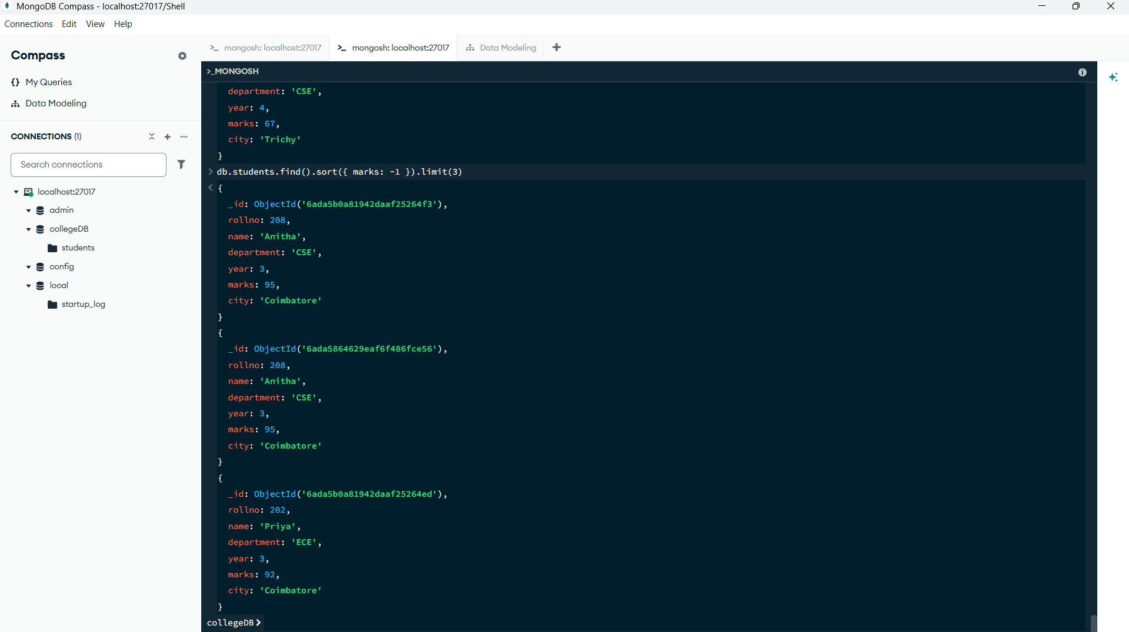

10. Count the number of CSE students.
db.students.countDocuments({ department: "CSE" })

11. Update the marks of one student.
db.students.updateOne(
{ rollno: 201 },
{ $set: { marks: 90 } }
)

12. Add a status field to all CSE students.
db.students.updateMany(
{ department: "CSE" },
{ $set: { status: "Active" } }
)
13. Delete a student using roll number.
db.students.deleteOne({ rollno: 210 })

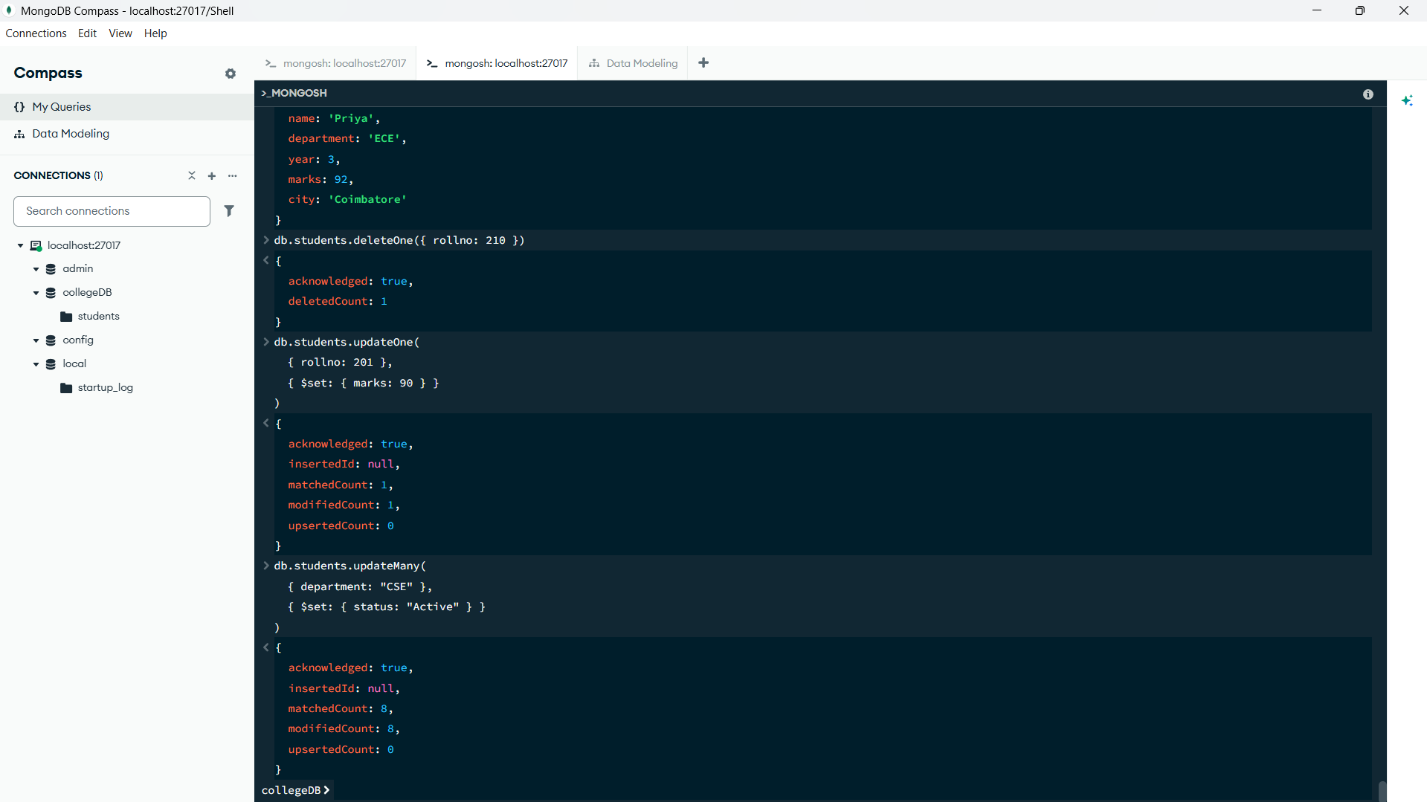

14. Display the distinct departments.
db.students.distinct("department")

15. Calculate department-wise average marks.
db.students.aggregate([
{
$group: {
_id: "$department",
averageMarks: { $avg: "$marks" }
}
}
])
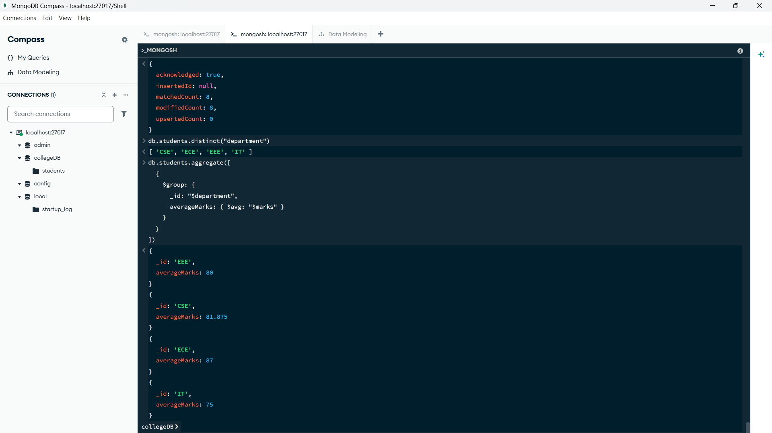

35. Suggested Viva Questions
1. What is the difference between a MongoDB collection and an RDBMS table?
A collection stores flexible, schema-less documents, whereas a table stores rows with a fixed structure of columns.
2. What is a MongoDB document?
A document is a single record stored as key-value pairs (JSON/BSON format) inside a collection.
3. What is the purpose of the _id field?
It uniquely identifies each document (like a primary key) and is auto-generated if not supplied.
4. What is the difference between find() and findOne()?
find() returns all matching documents, while findOne() returns only the first matching document.
5. What do $gt, $lt, $gte, and $lte mean?
They mean greater than, less than, greater than or equal to, and less than or equal to, respectively.

6. What is projection in MongoDB?
Projection selects which fields appear in the output (1 to include a field, 0 to exclude it).
7. What is the difference between updateOne() and updateMany()?
updateOne() modifies only the first matching document, while updateMany() modifies all matching documents.
8. What does the $set operator do?
It adds a new field or changes the value of an existing field in a document.
9. What does the $inc operator do?
It increases (or decreases) a numeric field by a specified amount.
10. What is an aggregation pipeline?
It is a series of stages (such as $group) that process documents to produce summarized results like averages, totals, and counts.
11. Why are indexes used in MongoDB?
Indexes speed up queries by avoiding a full collection scan.
12. What is the difference between deleteOne() and deleteMany()?
deleteOne() removes the first matching document, while deleteMany() removes all documents matching the filter.

Result
Using mongosh, a database (collegeDB) and a collection (students) were created, and CRUD operations, querying, sorting, aggregation, and indexing were performed successfully.

